Loadlesslbs colour scheme

1. HEADER/FOOTER



PURITAN GREY

1. NAVIGATION BAR

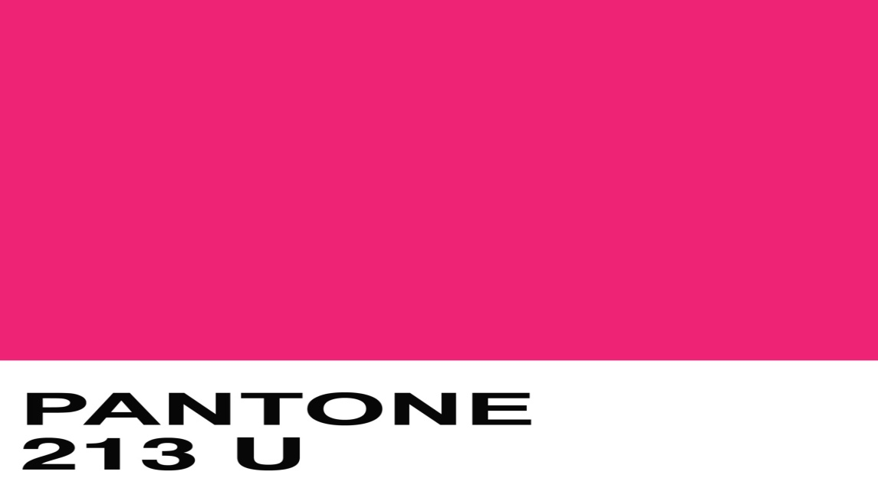

1. BAGROUND

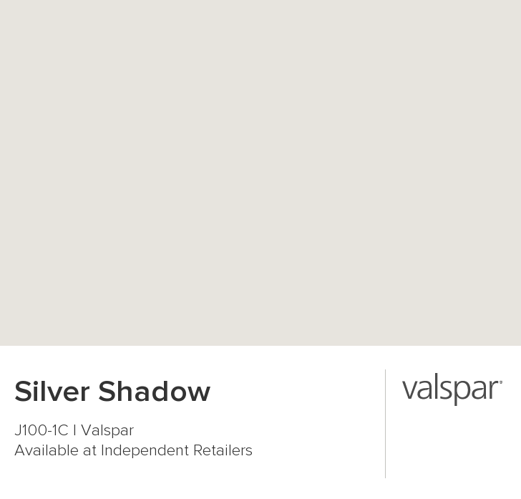

LAYOUTS

1. DEFAULT

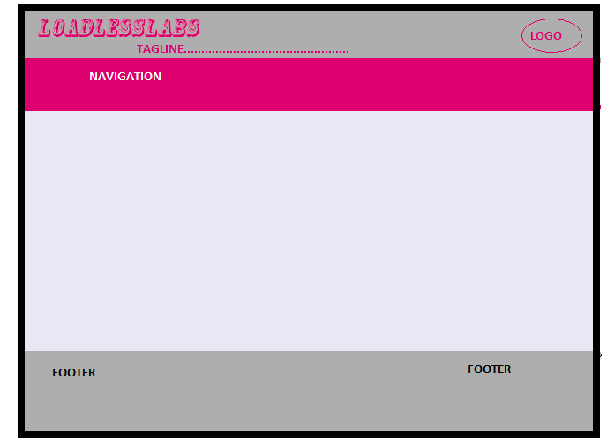

1. HOMEPAGE BEFORE LOGIN(LOGIN PAGE)

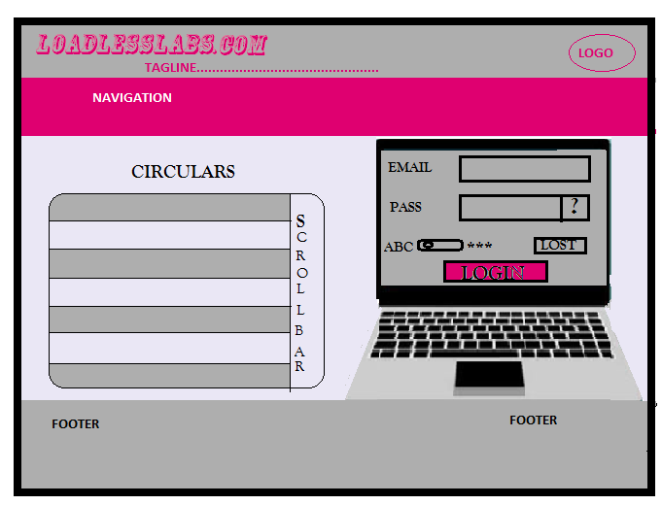

1. AFTER FIRST LOGIN (REGISTRATION)

